Item 8.
Private & Confidential: NO
Date: 25th May 2016

LEP Boost Business Lancashire Annual Report
Report Author: Andy Walker, Head of Business Growth LCC

Executive Summary

In 2015, the Department for Business Innovation and Skills (BIS) made a revenue grant to each of the 39 emerging Growth Hubs in England. This payment was aligned with but not part of the Growth Deal. As a condition of this funding, BIS requested that an Annual Report be prepared and signed off by the LEP before submission.

The body of this report contains the submission we have made.
BIS have made a further offer of revenue grant for 2016/17 and 2017/18 and similar reporting requirements will be in place to account for the use of this resource. Given that BIS have developed a standard template for the submission of data, we should then be able to compare performance across hubs.

Recommendation

The LEP BSM Board is asked to:
- note the Report,
- approve its submission to BIS

Boost Business Lancashire
Annual Report 2015-16

Overview and Summary

Boost Business Lancashire is Lancashire's Business Growth Hub, targeting a range of support services on the county's high growth companies. It has operated since April 2013 and has delivered a range of business support programmes, funded through a combination of ERDF, BIS and Lancashire County Council’s own resources, up to October 2015. Lancashire County Council has now been successful in applying for ERDF funding to deliver a new suite of programmes for a further 3-year period from January 2016, although because of the need to procure delivery partners, in effect the new phase of Boost activities commenced in March 2016.

This report covers 2015-16, the final year of the initial three-year Boost project, and looks forward to the next iteration of the growth hub whose design has been heavily influenced by the experience over the past three years. Therefore in addition to the figures for the past 12-month period, the report also highlights the main achievements of the previous three years.

The overall objective of the Boost project is to improve the competitiveness of SME within Lancashire. The project is focused on growth – encouraging individuals who have the potential to set up high growth businesses and supporting existing businesses that have the capacity for growth. The specific aim of Boost Business Lancashire is to accelerate the growth of Small to Medium sized enterprises (SMEs) in Lancashire, to stimulate new investment and job creation by systematically identifying and removing the barriers to their growth, by encouraging innovation and in promoting enterprise.

Throughout the development of Boost we have been conscious of the need for the business support offer within Lancashire to be directly relevant to the needs of businesses, and to be easily understood. In this regard we have worked in closely in partnership with the public and private sectors to develop initiatives that complement the existing business support infrastructure.

In each case we handle, it is the role of Boost to help businesses to pinpoint the barriers to their growth and to help them overcome these.

The core objectives of Boost are therefore:

- To devise a programme of business support that will encourage the growth of Lancashire SMEs;

- To encourage business support agencies to work together to provide a coordinated and easily understood business growth offer;

- To promote a programme of high quality business support to Lancashire SMEs;

To achieve this, our approach has been to:

- bring together a selection of services for pre-starts, start-ups and established businesses;
- use centralised marketing to reduce confusion and direct clients towards a central gateway;
- stimulate demand, better understand beneficiaries’ needs and refer clients to support (both within and outside of Boost);
- ensure a consistent client experience, while accommodating alternative entry-points into the programme through a standardised approach to diagnosing business needs and CRM system;
- focus on businesses, or business ideas with high growth potential.

Over the past three years, six individual programmes have contributed to the overall delivery ’offer’ from Boost, ranging from support for pre-start individuals to management and leadership support for managers with high growth aspirations.

Over the past 12 months Boost has dealt with 411 business cases, creating 669 new jobs and has helped to launch 102 new businesses. This builds on our achievements since Boost was launched in 2013. Over that 3-year period our overall targets were to reach out to 3000 businesses, to support 1477 cases involving 1269 unique business assists plus 208 pre start supports. In the final analysis, we dealt with 2962 businesses, delivering 1560 interventions to 1274 unique businesses plus support to 286 pre start individuals.

A. Progress to date

Governance

In terms of governance, the Lancashire Enterprise Partnership is responsible for the allocation of EU funding for business support within Lancashire and for the coordination of business support activities across the LEP area as it relates to its Strategic Economic Plan. Boost, the Lancashire Business Growth Hub is accountable to the LEP in respect of these two elements. It is also responsible to Lancashire County Council, in respect of the match funding that the local authority provides for Boost, and to BIS in relation to its funding.

Lancashire Enterprise Partnership (LEP) - Lancashire Business Support Management Board

The board has been established by the LEP with a remit to consider skills development and related business support priorities across the LEP geography, specifically to:
- Develop and promote business support strategy, initiatives and programmes aligned with agreed priorities, as part of the LEP's Strategic Economic Plan;
- Seek to co-ordinate and commission a publicly funded business support offer that is clear, fit for purpose and which complements both commercial and national offers.
- Commission and maintain an evidence-base to help understand key business support demands in the LEP area;
- Identify and work with other LEP areas on business support issues of strategic and cross-boundary significance; and
- Advise on the deployment of business support funding directly accessed or influenced by the LEP and make best use of public investment in this policy area.

The board is private sector led and comprised of between 4 and 10 representatives of business membership organisations (e.g. Chambers of Commerce, Federation of Small Businesses) and senior business people drawn from the overall LEP board.
Although not directly responsible for allocating funding, the board has an important role in influencing and guiding the coordination of business support in the area and in the provision of informed views to the overall LEP board regarding priorities for intervention. Boost reports quarterly to the Board in relation to its key performance indicators and in respect of the business support simplification agenda. The Board take an active interest in the performance of Boost and its impact on the Lancashire economy, mainly in terms of jobs and GVA.

The Delivery Framework

The delivery model for Boost over the past 3 years has been a combination of serviced delivered by core partners under service level agreements with public sector providers and procured services, delivered by private sector partners. The Boost Partnership has been made up of:

- University of Central Lancashire (Innovation Clinic) – [Partnership arrangement]
- University of Lancaster (Lancashire Forum, Leadership and Management project) – [Partnership arrangement]
- Regenerate Pennine Lancashire (Boost Gateway and Growth Sectors Support) - [Partnership arrangement]
- Community and Business Partners (Growth Mentoring) – [Procured service]
- Winning Pitch (Growth Accelerator) – [Procured service]
- Winning Pitch (Lancashire LEAP – Business Start Up project) – [Procured service]

Each partner had its own delivery team, comprising full-time and part-time staff together with specialist advisors and consultants.
Each partner was given specific targets at the start of the project that would contribute to the achievement of the overall target outputs. The partners have all worked well together to delivery Boosts objectives and targets. This has been underpinned by regular performance management meetings in the form of the Boost Operational Group – this Group has met monthly throughout the life of Boost to consider progress against targets and to take remedial action where needed. The Group has also been an important forum for sharing information and promoting discussion between partners.
The Hub Gateway – the intended route for business to contact the growth hub, has comprised of a small team of staff based in regenerate in Accrington, whose role has been primarily to help assess the eligibility of business to participate in the Boost project and to signpost them, either to the most relevant Boost strand or to other business support, including national organisations such as UKTI and MAS, and regional projects such as Assess to Finance. The Gateway has also established two way referrals with the Business Growth Service nationally and the Business Support Helpline.
The Gateway is backed by a freephone helpline and the Boost Web portal, which enables businesses to access services online or to register for more intensive Boost support. In practice most diagnostic activity has been undertaken remotely with the face-to-face contact with businesses being conducted by delivery partners.
The Boost Website
The website for Boost provides a comprehensive source of information for businesses, from a directory of business support products to a calendar of business support events. It also provides an online magazine containing the latest information and case studies of businesses who have benefited from Boost support. The site provides links to regional and national business support, and acts as a portal for those businesses wanting to access more in depth support to help them grow.
Summary of Boost Business Support ‘offer’
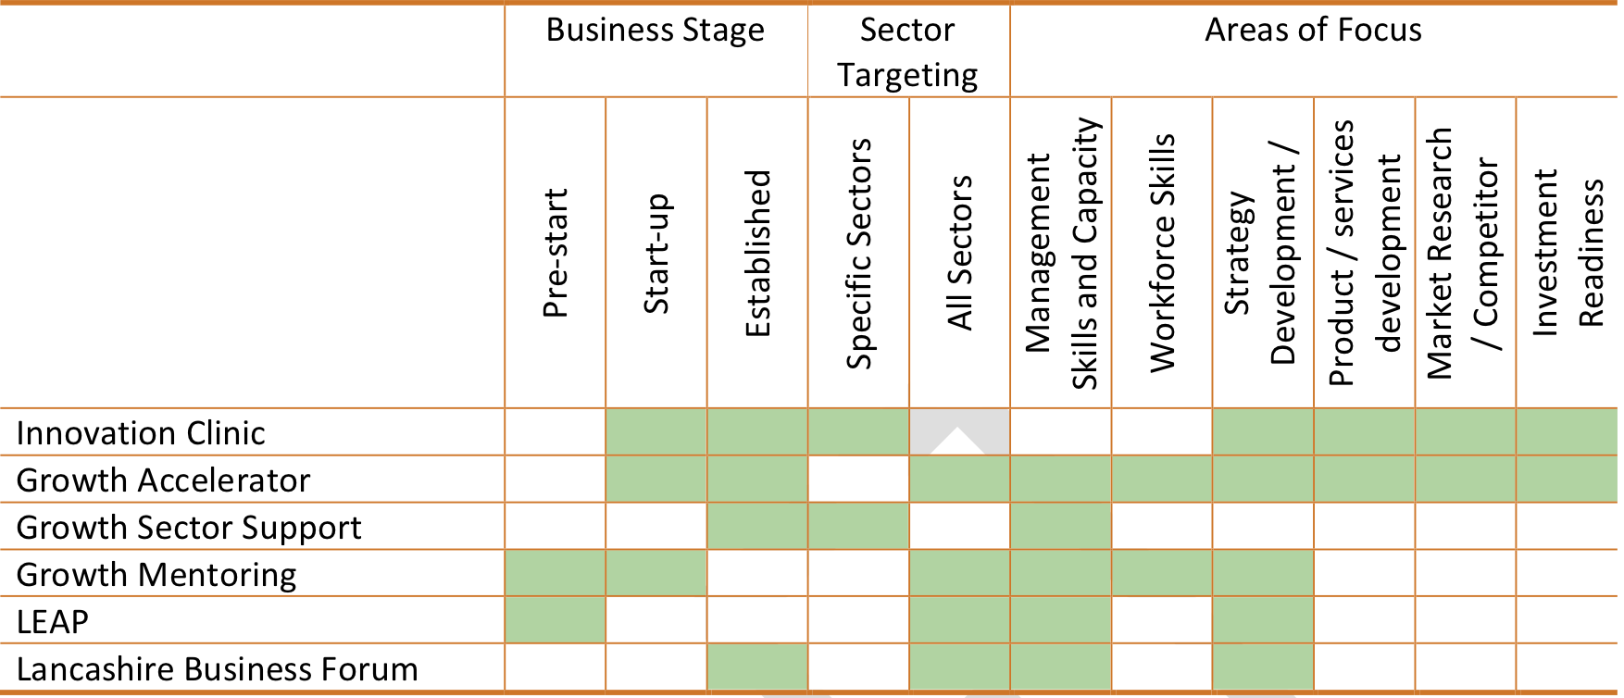

The Client Journey
Clients have been able to contact Boost directly through a number of channels – via the website, the Gateway telephone helpline or in person. They have been referred from intermediary agencies such as solicitors or accountants, or they may have been referred from one or other of the delivery organisations or other Boost affiliated initiatives. All companies contacting the Gateway has undergone a diagnosis of need to establish Boost eligibility and determine the most appropriate onward support programme, both considering Boost and external offers. At this stage their eligibility to access one of the Boost core offers is be assessed. In many cases it is anticipated that the Gateway team of advisors were be able to deal with the enquiry at source or to refer the company or individual onto the most appropriate support organisation.

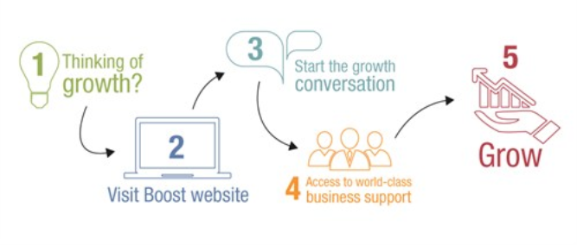
B. Key Achievements

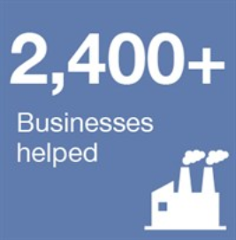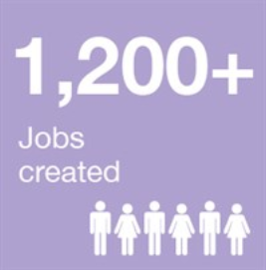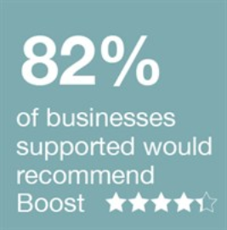

Headline achievements

Overall Boost has been a very successful project and has for the most part met its target outputs and core objectives. We have confined our business engagement activities to companies with growth potential and whilst this has created tension with those businesses who fall outside this definition (who wanted access to Boost services), it has meant that we have been able to secure a high proportion of businesses actually demonstrating growth.

The number of businesses assisted to improve their performance has been the headline target for Boost. The target represents those businesses that satisfy the gateway criteria as being Boost eligible (satisfying ERDF criteria and being growth oriented), and who have been referred for more intensive support to one of the Boost partners. At the outset, Boost set out to help 3,000 businesses over a 3-year period. In the event, some 2951 businesses were supported in the 2.5 years to December 2015.

Considerable effort has been expended to monitor performance against the headline target and to inform and drive the marketing effort to generate a steady stream of businesses to Boost.

The project has met its overall target for 2013-15, with 1274 unique business assists being recorded against a target of 1269. As a programme that was launched at a time of economic recession, Boost has made a significant contribution to the growth of SMEs in Lancashire, with 909 of the 1274 businesses assisted demonstrating improved performance and over £50 million of additional GVA secured for the Lancashire economy.

Annual targets for each of the outputs were not set for Boost, as these lag considerably behind actual activity. Rather a monthly profile of client engagement and referrals were used to drive business traffic to the delivery partners. Progress against the three-year output targets that had been set at the start of Boost were however monitored and reported at the Operational Group each month, and to the LEP Business Support Board each quarter. The following table shows the actual achievements in the past 12 moths and over the three-year life of Boost.

Boost Business Lancashire 3 year targets and achievements (2013-15

Indicator | Achieved 2015-16 | Targets 2013-15 | Achieved 2013-15
A. Pre-start individuals assisted | 22 | 208 | 286 (137%)
B. Businesses assisted to improve their Performance | 411 | 1269 | 1274 (100.1%)
Total number of business assists (A+B) | 433 | 1477 | 1560 (105%)
Businesses with actual improved performance | 849* | 795 | 909 (114%)
Jobs created | 669* | 1468 | 1166 (80%)
Jobs safeguarded | 334* | 461 | 294.3 (64%)
GVA increase | £48.53m* | £18.1m | £50.94m (281%)
Businesses created | 102* | 180 | 104 (58%)
People assisted with skills | 32 | 450 | 450 (100%)
* Note – achievement of certain Boost outputs in 2015-16 are as a result of activities in the previous two years due to the time lag in the collection of data.

The target for the number of new businesses launched by Boost was 180. It was somewhat disappointing that at the end of the project 104 new businesses had been recorded. In mitigation, the delivery partner (Winning Pitch) reported that recent monitoring shows that the number of new business starts is projected to rise significantly in the early part of 2016, as many individuals who have participated in the LEAP start up programme in the latter half of 2015 intend to commence trading in 2016.

The conversion rate of 36.4% new businesses from 286 individuals who received pre-start support is less than may be expected for this type of support programme. The lessons in providing pre-start support during the lifetime of Boost have been used to enhance the design of the start-up programme for Boost during 2016-18 in order to improve this conversion rate. Greater emphasis will be placed on the viability and sustainability of new businesses and in subjecting the business plans of new starts to much more rigorous scrutiny.

In addition to recording jobs created, Boost has monitored those instances where businesses have made a direct link between the support received from the Lancashire Growth Hub, and the safeguarding of jobs within their businesses. Whilst the achievement of 294.3 jobs safeguarded against the target of 461 may seem somewhat disappointing, it should be remembered that Boost has operated against a backdrop of the UK economy emerging from a deep recession, and most businesses supported by Boost have either recorded significant new jobs, an increase in GVA, or other growth related activities.

The apparent underperformance in jobs safeguarded is therefore more than offset in terms of the numbers of businesses demonstrating improvement and the level of GVA secured.

The measure of improved Gross Value Added (GVA) is an important indicator of growth in the Lancashire economy through increased economic activity. The methodology for recording GVA is well established and within Boost the evidence has been gathered directly from the SMEs supported.

The programme target of £18,100,000 has been over achieved by a factor of 281%. Some £50,943,000 of increased GVA has been reported by 407 businesses supported through Boost since July 2013. This is a significant achievement, particularly at a time of economic recovery, and provides a good platform for the new phase of Boost from 2016 onwards.

This growth has not resulted in as high an increase in employment in the businesses concerned as might have been expected. This is attributed to businesses being more cautious as the economy moves out of recession, investing in more efficient production methods and processes rather than in job creation.

Client Satisfaction

In December 2015, Regeneris Consulting invited Boost’s clients to complete an online survey to gauge their opinions of the programme and to gain an understanding of how Boost has impacted their business performance. The survey received 138 responses (a response rate of 12%) and carries with it a margin of error of 8% at the 95% confidence level. This should be borne in mind when interpreting the results.

To supplement the online survey, Regeneris Consulting carried out a small number of in-depth interviews with a selection of clients. These were selected from the clients that had reported the most substantial impacts, either in response to the survey or in Lancashire CC’s monitoring data, so they are not a representative group. The purpose of these conversations was to explore the factors that have supported impact and understand the ways in which businesses have benefited from the support on offer and explore what might have happened to these businesses in the absence of their work with Boost. It should be noted that although the data was gathered in December 2015, the businesses surveyed could have received help from Boost at any stage since 2013.

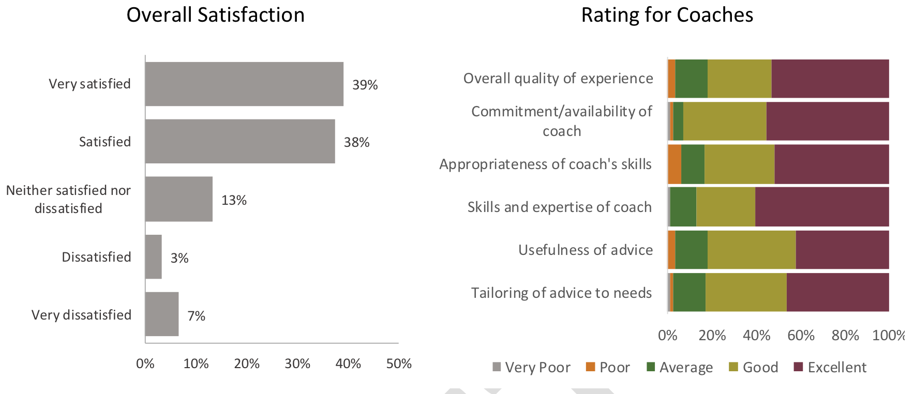

It is encouraging to note that some 77% of clients were satisfied or very satisfied with the support they had received from Boost, and only 10% expressed dissatisfaction. This does however indicate room for improvement and more robust client satisfaction measures are now being built into the Boost CRM system to allow feedback to be picked up and acted upon at an earlier stage, rather than at the end of the programmes. Businesses were also pleased overall with the quality of the individual advisors, with most receiving good or excellent ratings. It is also significant to note that 82% of companies supported would recommend Boost to other businesses.

Impact

The survey carried out by Regeneris asked respondents to reflect upon any changes to turnover, employment and productivity since receiving Boost support and to consider any future changes in business performance yet to materialise.

A considerable proportion of businesses reported changes in turnover, employment and productivity since working with Boost. Almost one third of businesses reported that they had not yet seen a change in any of these indicators. This is most likely a reflection of the large number of businesses that have received support relatively recently. The assistance that these clients have benefitted from has yet to bring about changes in business performance. This is certainly implied in the responses that show that the majority of clients reporting no change in business performance had been assisted recently, i.e. in 2015.

The survey responses suggest that there will be further impacts on business performance to come. The proportion of businesses expecting further growth is substantially higher for each of the three performance indicators whilst fewer businesses expect no changes in the future.

While impacts observed to date are relatively small, there are encouraging prospects for the next three years. Although over half of respondents expect revenue to rise by less than £100k, approximately 20% of businesses reported future turnover increases are expected to be in excess of £1m. Similarly, although there is a notable concentration of businesses that anticipate minor employment increases, over one fifth of respondents forecast employment to increase by between 10 and 49 workers over the next three years.

It is also very encouraging to observe the extent to which respondent acknowledge the contribution of Boost in helping them to achieve their growth objectives, with 90% of businesses stating that Boost had a positive impact on their growth:

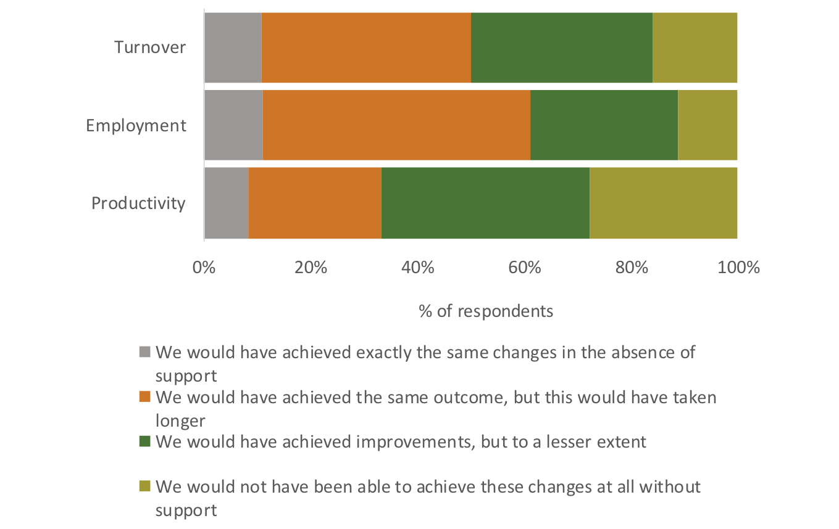

C. Contribution to Business Support Simplification

Simplifying Business Support
The Lancashire Enterprise Partnership through its Business Support Management Board is trying to ensure that there is a coherent business support offer in Lancashire which:-
- Meets the identified needs of businesses and allows them to grow
- Is clear and easily navigable
- Makes best use of limited public resource
- Doesn’t “crowd out” private sector activity

Boost – Lancashire’s Business Growth Hub sits at the centre of this and is resourced to fully understand what business support is available, to conduct and manage a dialogue with businesses to determine a hierarchy of needs and to draw in those who are not currently using business support services. Over the past 3 years we have listened to businesses regarding the nature of business support they require and have reflected this in the design of our programmes. We have also commissioned interim and final evaluations of Boost in its initial phase of delivery, and we have used all of this feedback to redesign Boost from 2016 onwards.

In terms of building on the experience of Boost, we intend to build on the good practice and successful approaches that we have developed over the past 3 years, and respond to the feedback from Lancashire businesses on the kind of support that they have valued most.

Boost is central to the Lancashire Enterprise Partnership's aspiration to develop an infrastructure of publicly funded business support which is simple, well understood by business and genuinely drives the growth of SME's within the sub-region. Boost has been the subject of close monitoring and continuous operational review (via our monthly Operational Group). We have used our experience and the feedback from Lancashire’s SME community to amend the delivery model.

We propose to strengthen and improve the ‘Gateway’ function – the point at which most businesses will initially interact with the Growth Hub. In addition to the core functions – telephone helpline, website and CRM system, we have introduced a new IDB role for the Gateway, where the needs of SMEs can be more accurately assessed, enabling them to be directed to the most appropriate support for their growth needs. This could be to one of the Boost core ‘offers’, to national and regional programmes, or to other appropriate support.

We have also significantly redesigned the pre-start element of Boost to improve the conversion rate from businesses engaged to actual new businesses being launched.

Mapping Business Support in Lancashire

To support the simplification process and to identify how businesses access relevant support, during January 2016 a survey was issued to 8083 Lancashire businesses with the aim of obtaining:

- an understanding of levels of different types of support received and views of historic business support received, if any
- views of what type of support might be useful in the future
The data set was established from two main sources - 6131 business and potential start-up individuals that had had contact with Boost Business Lancashire (delivered by a range of partner organisations) and earlier programmes delivered by Regenerate Pennine Lancashire (going back to 2011). These records were drawn from the Evolutive database that is well established as the common client management system for the Lancashire Growth Hub. An additional 1952 records were acquired in order to obtain a data sample of businesses that were not known to have previously accessed business support.

37 local business support providers were also invited to complete an online survey followed up with a number of email and telephone reminders. 21 responses were received covering 35 distinct support offers spanning a range of support including, advice, mentoring, workshops, grants and skills. 56% of support offers were targeted specifically at existing businesses with 40% aimed at those considering starting a business.

38% of respondents reported that they had received publicly funded business support whilst 62% stated that they had not. This split is perhaps initially surprising, given that the majority of the dataset was drawn from a database of previous contacts. This is indicative of the fact that many business do not recognise the source of their support. However the dataset included any contact with a range of business support programmes, including those that did not ultimately receive support either through their own choice or for reasons of eligibility.

Over half of respondents stated that they were either not aware of any available support or more specifically that they had not been aware of any relevant support at that time that it would have been needed. Those who stated “other” were asked to provide comments. The comments ranged from issues around eligibility, frustration with attempting to obtain support and a number of respondents that reported that they actually provided business support themselves.

The lack of awareness is a particular concern, as most business support programmes do undertake marketing and promotional activities to seek to engage with relevant potential beneficiaries via a range of channels. Effective engagement, particularly with those who have not previously engaged with business support remains a key challenge for business support programmes.

Respondents were also asked what types of business support they would like to see in the future and were allowed to select up to 3 options. The chart below shows a broadly even spread of support types with exceptions for accessing growth finance (20%) and sales and marketing support (16%).

Overall there was good awareness amongst respondents of the name of the support programme they had benefited from and the organisation that had provided it. With the range of business support schemes and providers, there was inevitably some confusion and misunderstanding most had at least an approximate idea of the support and provider. Boost Business Lancashire, Winning Pitch and Regenerate were particularly well represented in responses, which reflects the dataset used in the survey.

A percentage breakdown of the type of business support received across the 115 instances shows a strong weighting towards grant funding, followed by business growth and start up support. The “other” responses included businesses that had been supported via the recent flood recovery and resilience programmes.

In terms of satisfaction with business support, 62% of respondents reported that they had never received any external business support with over half of those reporting a lack of awareness of any relevant support that may have been available. Of the 38% of businesses that had received support, grants and business growth support were the two most common types of intervention. 75% of supported businesses reported a positive impact with a similar proportion stating that they would recommend the support to peers. Of concern is the number of businesses that stated that they had not received support due to lack of awareness and the quarter of those that had received support not deeming it good enough to consider recommending it to peers.

It was encouraging that 62% of business support experiences were rated as either excellent (40%) or very good (22%) with only 15% poor (8%) or very poor (7%). It would be encouraging if a future survey based on the new round of emerging support programmes could see the negative views reduced to single figures. Respondents were also largely positive regarding the impact that the support had had on their business with 75% reporting either a positive or very positive impact. 76% of respondents stated that they would recommend the support they had received to other business contacts, although 22% reported that they definitely would not.

Lancashire Business Support Provider Survey

The survey of Lancashire business support providers was undertaken during February and March 2016. The aim of the provider survey was, in part, to gather up to date information on current and emerging business support offers from local providers. The information will be used to update the Boost Business Lancashire Support Finder resource. The support finder will be openly available via the Boost web site and will also be used by Gateway advisors in helping to recommend appropriate support offers. Additionally the survey sought providers’ views on what they saw as the current issues and priorities in relation to start up and business support in Lancashire.

The survey was circulated to 37 organisations in mid-January 2016 and was followed up several times by both email and telephone. 21 of the contacted organisations provided responses, submitting information on a total of 35 distinct support offers or programmes. Not all responses were from organisations originally contacted, as there was some helpful sharing of the survey between organisations (e.g. onward circulation by Manchester Growth Company).

Although the survey was aimed at gathering information about public sector funded business support, 29% of respondents identified themselves as private sector. This is not inconsistent as private sector organisations are also involved in the delivery of support using public funds. Most support programmes were available to businesses across Lancashire. A small number were limited to a subset of borough council areas, usually divided on an east/west geography. Some borough councils offer support that is specific to their own area.

41% of the support offers were specific to SMEs with the remaining 59% being available to businesses of any size. No support was available to large companies that wasn’t also available to SMEs.

A majority of support (56%) was available only to existing businesses but pre starts were well catered for, being eligible for 40% of the support recorded via the survey. Support was either available to all business sectors (57%), or a range of priority sectors excluding retail. Only one retail specific scheme was recorded in the survey.

Where financial support was offered in the form of grants, the minimum grant offer ranged from £200 to £10,000 and the maximum offered ranged from £500 to £1m. The minimum loans offered ranged from £500 to £5000 whilst the maximums ranged from £500 to £150,000.

The key deliverables from the support offers were heavily weighted towards the creation of new jobs (29%).

Most programmes that provided an end date were due to end in either 2017 or 2018.
Finally, providers were asked for any additional comments they had regarding business support provision in Lancashire with 10 providing a response. Key points raised included:

- A lack of non high growth potential (generic) start up provision
- A lack of support for retail businesses.
- A lack of support providing mentoring to non high growth potential companies.
- The demise of national products, although one respondent provided an update on plans to seek funding to provide a North West equivalent of the former Manufacturing Advisory Service national offer.

Key findings and recommendations from the survey
A survey report has been produced which covers these issues in more detail. The full report is being presented to the Lancashire Enterprise Partnership for separate consideration, however its main recommendations are summarised below:

- The Growth Hub Gateway should have a key role in considering how private sector business support can complement publicly provided support as part of its information diagnostic and brokerage function.
- It is recommended that consideration be given to the establishment of a flexible Lancashire wide capital fund that aligns with existing Rosebud provision, such that a small percentage of any offer may be in the form of a grant, whilst the majority is the subject of a loan agreement.
- Consideration should be given to
  - The provision of more flexible/generic start up and early stage business support.
  - More diligent scrutiny of applications for high growth support to provide reassurance, as far as is possible, that the proposed business idea really does have high growth potential.
  - More in-depth evaluation of high growth start up programmes to check whether the proportion of businesses that started up and sustained is significantly better than a “do nothing”
  - More in depth evaluation of high growth start up programmes to determine how closely actual beneficiary company performance aligned to growth projections outlined at the outset of the support.
- Programmes should only be funded where an evidenced demand can be demonstrated and should come with a robust marketing plan that coordinates with the overall marketing and engagement activity of the Lancashire Growth Hub Gateway service.
- There is currently a gap in Lancashire for an independent (i.e. non institution specific) innovation and technology support offer. National provision may fill this gap but experience has shown that the most effective engagement by national offers has resulted when there has been a local support presence to introduce and guide the national offers. Consideration should be given to whether this role can be fulfilled via the Lancashire Growth Hub Gateway advisors, or whether dedicated provision may be required.
- There is a key role for the Lancashire Growth Hub Gateway service in maintaining up to date and detailed knowledge of existing and emerging support in order to ensure effective coordination and the avoidance of duplication.
- The role of the Lancashire Enterprise Partnership’s Business Support Management Board in informing the LEPs feedback and commentary of proposed and active Lancashire Programmes should be more formally established.
- Funding and delivery agreements should give consideration to a greater degree of results based payments, rather than simpler but potentially less effective payment by volumes of throughput models. These should be backed by closer performance monitoring and the inclusion of contract break points during project delivery.
- Effective evaluation should be intrinsic to any project. This should include evaluation of the initial premise for the project compared to actual activities, delivery arrangements and performance and the tangible impacts for the beneficiaries. Evaluation should take place at the appropriate time and be staged if necessary, for example, some impacts may be immediate whilst others may only be realised over a longer period.
- Local funding decision makers should pay particular attention to the following in terms of potential scope for duplication, inconsistency and confusion - Start up support and Financial products – e.g. loans, grants.
- The renewed Growth Hub Gateway service needs to play a key operational role in ensuring effective alignment and coordination between national and local business support offers. This is important to:
  - ensure appropriate Lancashire companies receive sufficient benefit from national offers.
  - Achieve joined up delivery, avoiding overlap and “initiative” fatigue. The local team can help to deploy the appropriate national resources in a timely manner and may often make linkages that national programme representatives may not have achieved without the benefit of local knowledge.
- Specifically, there should be closer working between the Growth Hub Gateway and the deliverers of the New Enterprise Allowance Programme. For example, further support may be needed by the NEA beneficiary either in parallel with the NEA support or after it has ended.
- Most support has relatively broad eligibility or exclusions. Consideration should be given to whether there is a requirement for specific support provision to benefit particular Lancashire growth sectors

D. Record Keeping and Evaluation

In order to monitor the performance and impact of Boost, we maintain a comprehensive database – a CRM system that records all contacts with businesses and captures essential information on each individual or business we support in order to tailor the most relevant support to them. When all companies sign up for support from Boost, they consent to the information given and held on the CRM system being shared with funding bodies and business support providers.

Over the period 2013-15, Boost has also been the subject of two independent evaluations, carried out by Regeneris, the economic development consultancy. The first of these, an ‘interim’ evaluation was carried out in 2014, when Boost had been operating for 12 months. The second report – their ‘final’ evaluation was carried out at the end of 2015.

The interim evaluation highlighted the initial slow start in meeting targets for expenditure and outputs, and recognised the early issues around the Growth Hub establishing itself as the new focus for business support in Lancashire, nevertheless it reported good levels of customer satisfaction. To a large extent the findings of the evaluation were a consequence of a slow start in setting up the systems and processes needed to manage the requirements of the ERDF funding, and the need to undergo a lengthy procurement process for some of the delivery strands. In particular the project was affected by delays in establishing the national Growth Accelerator programme, which provided some of the match funding for Boost.

Also, it should be understood that at the time of the interim evaluation, because of the time lag between support given to businesses, and the outcomes being realised, much of the impact from that early period of activity could not be recorded until later in the lifetime of the project.

Over the intervening period however significant effort has been expended in establishing the credibility of Boost and in bringing the initiative back on track with its performance targets. The final evaluation reports highlights the good progress made in aligning the target and actual performance figures. CLG in their outturn evaluation of Boost were extremely pleased with the progress made and the contribution made to the ERDF Operational Programme.

Both evaluations are available for reference, but their main findings are summarised below:

Interim Evaluation (August 2014)

- Boost got off to a slow start and it will now be difficult to get spend and outputs back on track. The model is not working in the way it was expected to and Boost is not reaching the clients who are most in need of help to access business support;

- Although the volume of support delivered is less than expected, it is important to recognise that Boost’s clients are largely very positive about the services they have received and it appears to be having a positive impact on their performance;

- Although there no evidence to suggest that any substantial changes to the delivery strands themselves are needed, Boost does need to reflect upon how much it can realistically expect to deliver and where the underlying concept is heading;

- In the short term, Boost should focus on practical changes that will help to deliver the ERDF contract. Lancashire County council and partners do however need to be realistic about the scale of the challenge and the possibility that the short term fixes, could take Boost further away from the Growth Hub ideal.

Final Evaluation (December 2015)

- Boost was an ambitions project, with challenging targets and high expectations. It involved forming a new delivery partnership and faced the additional challenge of complying with the ERDF funding and reporting regimes alongside complex delivery arrangements;

- Boost under-performed in the initial stages (2103-14) but strong performance management in the 2014-15 period has enabled the project to reach its main targets, and it has made significant contributions to the Lancashire economy in terms of new jobs and GVA;

- Some of the focus on delivering contractual targets within a tight timescale has been at the expense of more strategic aspirations, such as focusing on high growth and in developing stronger partnerships;

- The Gateway did not perform to its full potential, in particular the important diagnostic stage was too light touch and process driven;

- The Evolutive CRM system was under-utilised by partners. In particular the time lag in entering data by partners meant that the system was rarely up to date and most of the data entry took place in the last few weeks of 2015. This made it more difficult to track clients and coordinate marketing activities;

- Clients were mostly satisfied but there is room for improvement;

- Whilst the outputs are good, the short-term impacts are modest. However the return on investment is expected to be positive, especially if the projected investment by businesses continues.

Going Forward

Today Boost is in a very different place from where it stood in 2013, at the start of the growth hub journey. The Boost ‘brand’ is now well recognised, and much has been learned about what works and what does not, and in particular what support businesses most value. The feedback from the two evaluation reports has been used to inform the design of Boost going forward.

Among the changes implemented or in the pipeline are:
- Performance measures now incorporated into delivery contracts
- An upgraded and refocused Gateway function with an enhanced Information, Diagnostic and Brokerage Role;
- A redesigned business start-up service to improve the formation rate of new businesses;
- A dedicated project management team within LCC including specialist ERDF funding expertise;
- A new business support coordination Group to link all Boost and other public funded Business Support projects;
- A new Memorandum of Understanding to be signed buy all ESIF funder business support projects;

E. Lessons Learned/Good Practice

Feedback from the Interim Evaluation of Boost, carried out in 2014 and 2015, together with feedback from consultation with SMEs and the views of partners at monthly management meetings have all contributed to the learning process. The most significant issues have included:

- The need for more robust training of delivery partners in using the CRM system;
- The need to clarify output definitions at the very start of the project;;
- Greater flexibility is needed for companies to move from one delivery strand to another;
- Better IDB activity during the early stages of intervention will avoid certain problems later on;
- The need to align the CRM system more fully with the quarterly claims process
- The need for more consistency in the way delivery partners maintain beneficiary files;
- Better screening of pre-start and early stage businesses is required;
- Better signposting of non-Boost eligible companies to other relevant support

Challenges we have faced include the amount of time and resources that have had to be allocated to the process of administering, claiming and disbursing the ERDF funding allocated to the project. In particular the eligibility checks on beneficiary companies and signposting businesses to single strands of support have been recurring issues (ERDF rules mean that businesses can only be supported once within a single project). The coordination of diverse delivery partners has also been a challenge.

Along the journey we have assembled a considerable knowledge bank of case studies, highlighting the barriers and obstacles that businesses have faced and how these have been overcome with support form the growth hub. In the next iteration of the project we intend to build on the good practice and successful approaches that we have developed over the past 3 years, and respond to the feedback from Lancashire businesses on the kind of support that they have valued most.

Our key assets going forward include:
- A well developed CRM system giving access to over 3000 records with the capability to support strong performance management
- Experienced delivery partners operating within tight performance frameworks
- A dedicated project management team including specialist ERDF funding expertise
- Clear support and strategic direction from the Lancashire Enterprise Partnership

